**EXPERIMENT NO.3**

AIM: To design the circuit of half subtractor.

IC USED: 7486(X-OR), 7408(AND), 7404(NOT).

THEORY: A half subtractor is a logical circuit that performs an subtraction operation on two binary digits. The half subtractor produces a Difference and a borrow value which are both binary digits.

A half subtractor circuit has two inputs X, Y and two outputs – D representing difference and B representing borrow.

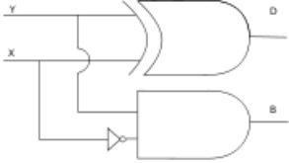

D = A xor B i.e. (A’B + AB’)

B = A’B

TRUTH TABLE:

| **X** | **Y** | **D** | **B** |
| --- | --- | --- | --- |
| 0 | 0 | 0 | 0 |
| 0 | 1 | 1 | 1 |
| 1 | 0 | 1 | 0 |
| 1 | 1 | 0 | 0 |

SCHEMATIC DIAGRAM:

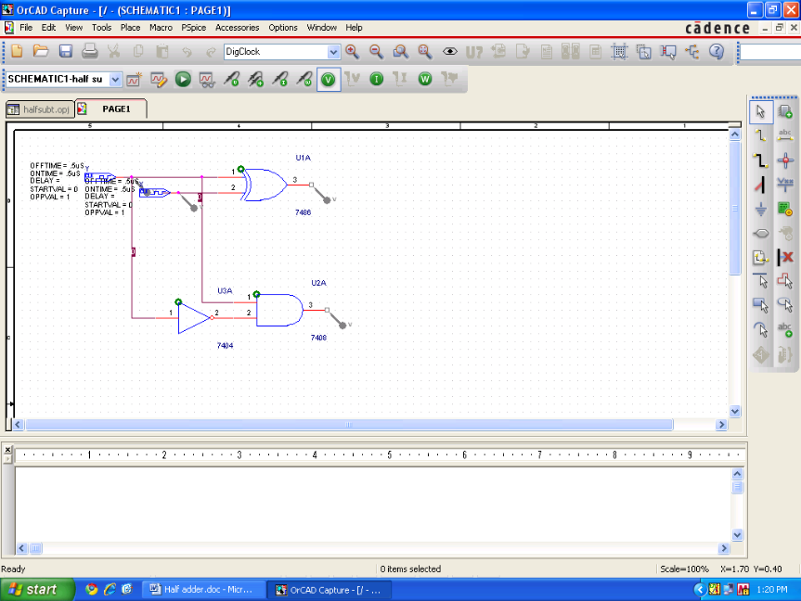

WAVEFORM:

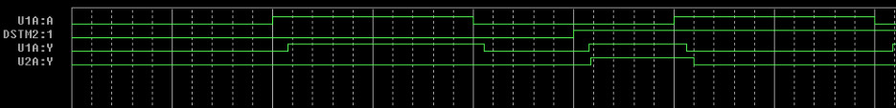

RESULT: The output waveform of half subtractor is verified.